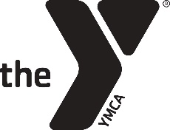 2018-2019 YMCA PRESCHOOL CALENDAR

August 9th – First Day of School
September 3rd – Labor Day
September 17th – Professional Development Day
October 8th – 12th – Fall Break
November 6th – Election Day
November 21st – 23rd – Thanksgiving Break
December 20th – January 1st – Christmas Break
January 21st – Martin Luther King Day
February 18th – Professional Development Day
March 15th – Professional Development
April 1st – 5th – Spring Break
May 16th – Last Day of School

We are following Graves County School Systems calendar for the year. This includes snow days. You will be informed of any additional closings at the preschool as soon as we are able to make the announcement.

