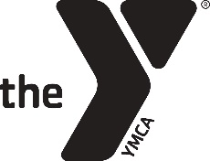 2018-2019 YMCA PRESCHOOL SUPPLY LIST

Welcome to Preschool! We are so excited to have you in our class. The following is a list of items that will get us off to a great start!
Each child will need to bring:
- Change of clothing to include pants, shirt, underwear, socks (seasonal)
- Rest Blanket (no large stuffed animals please)
- Standard size backpack for carrying folder, blanket, etc. to and from school (All items should fit comfortably in the backpack and the backpack should not have wheels.)
- 4 Elmer’s glue sticks
- 1 box of at least 24 crayons
- 1 pair of FISKAR blunt tip scissors
- Paint shirt (old oversized t-shirt for paint time in crafts)
- Pencil box
- 2 pocket folder
- At least ONE of the following:
  - 1 package of non-wax paper plates
  - 1 ream of white paper
  - 2 jars of play-doh
  - Variety stickers
  - 1 package of construction paper
  - 1 bottle of washable paint
  - 1 roll of scotch tape
  - 1 bottle of liquid glue
PLEASE MAKE SURE THAT YOUR CHILD’S NAME IS ON ALL OF THEIR ITEMS!

If you cannot afford these items, please let your preschool teacher know and we will work with you on obtaining them.

